 



Database Programming with SQL

* 1. : Working with Columns, Characters, and Rows Practice Activities

# Objectives

* + - Apply the concatenation operator to link columns to other columns, arithmetic expressions, or constant values to create a character expression
    - Use Column Aliases to rename columns in the query result
    - Enter literal values of type character, number, or date into a SELECT statement
    - Define and use DISTINCT to eliminate duplicate rows
    - Display the structure of a table using DESCRIBE or DESC
    - Edit, execute, and save SQL statements in Oracle Application Express

# Vocabulary

Identify the vocabulary word for each definition below.

|  |  |
| --- | --- |
| DISTINCT | A command that suppresses duplicates |
| Concatenation Operator | Links two columns together to form one character data column |
| Literal Value (String) | A group of character data |
| DESCRIBE | An SQL plus command that displays the structure of a table |

# Try It / Solve It

1. The manager of Global Fast Foods would like to send out coupons for the upcoming sale. He wants to send one coupon to each household. Create the SELECT statement that returns the customer last name and a mailing address.

**SELECT last_name as "Last Name", address || ', ' || city || ', ' || state || '-' || zip || CHR(10) || '(Phone-' || phone_number || ')'  as "Mailing Address"**

**FROM f_customers;**

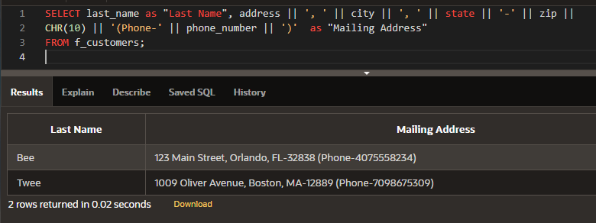

1. Each statement below has errors. Correct the errors and execute the query in Oracle Application Express.

a.

SELECT first_name

FROM f_staffs;

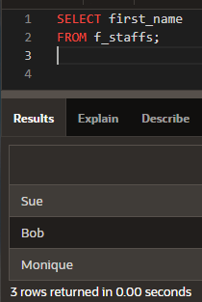

b.

SELECT first_name || ‘ ‘ || last_name AS "DJs on Demand Clients" FROM d_clients;

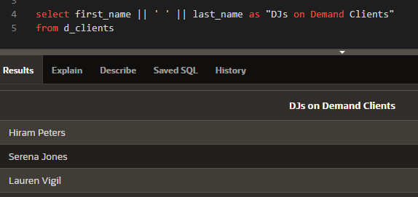

c.

SELECT DISTINCT quantity FROM f_order_lines;

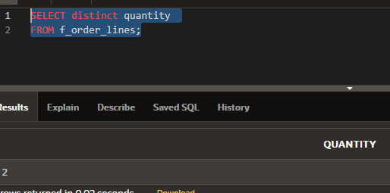

d.

SELECT order_number

FROM f_orders;

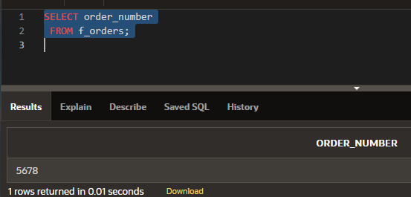

1. Sue, Bob, and Monique were the employees of the month. Using the f_staffs table, create a SELECT statement to display the results as shown in the Super Star chart.

|  |
| --- |
| Super Star |
| *** Sue *** Sue *** |
| *** Bob *** Bob *** |
| *** Monique *** Monique *** |

SELECT '***' || first_name || '***' || first_name || '***' as "Super Star"

FROM f_staffs;

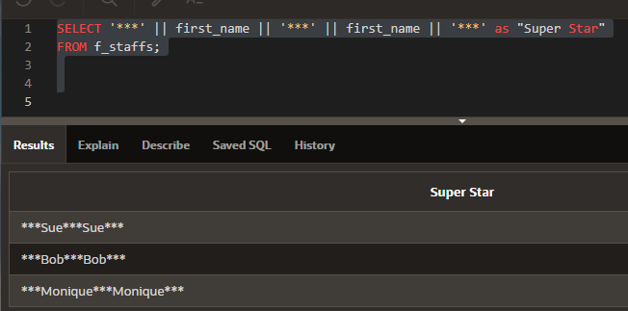

1. Which of the following is TRUE about the following query? SELECT first_name, DISTINCT birthdate

FROM f_staffs;

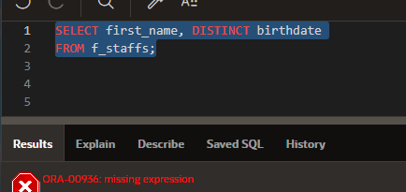

* 1. Only two rows will be returned.
  2. Four rows will be returned.
  3. Only Fred 05-Jan-1988 and Lizzie 10-Nov-1987 will be returned.
  4. No rows will be returned.

1. Global Fast Foods has decided to give all staff members a 5% raise. Prepare a report that presents the output as shown in the chart.

|  |  |  |
| --- | --- | --- |
| EMPLOYEE LAST NAME | CURRENT SALARY | SALARY WITH 5% RAISE |
|  |  |  |

SELECT last_name as "EMPLOYEE LAST NAME", salary as "CURRENT SALARY", ROUND(salary*1.05, 2) as "SALARY WITH 5% RAISE"

FROM f_staffs;

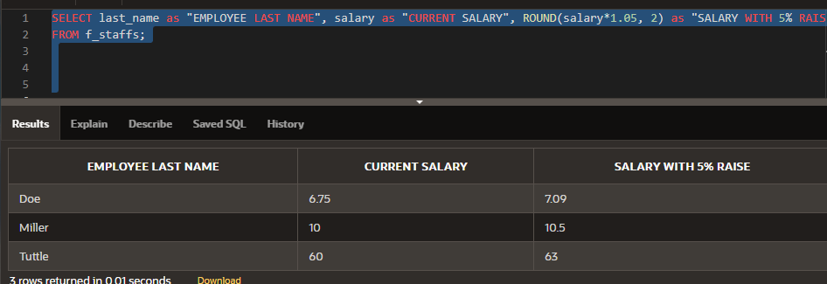

1. Create a query that will return the structure of the Oracle database EMPLOYEES table. Which columns are marked “nullable”? What does this mean?

DESCRIBE employees;

first_name , phone_number, salary, commison_pct, manager_id, department_id and bonus are nullable.

 It means that row is valid even if the fields corresponding to these columns do not contain any data.

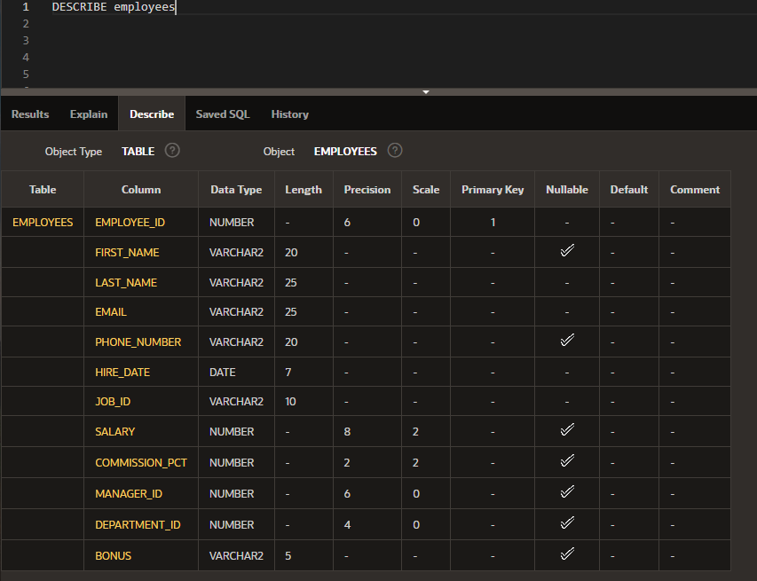

1. The owners of DJs on Demand would like a report of all items in their D_CDs table with the following column headings: Inventory Item, CD Title, Music Producer, and Year Purchased. Prepare this report.

SELECT cd_number as "Inventory Item", title as "CD Title", producer as "Music Producer", year as "Year Purchased"

FROM d_cds;

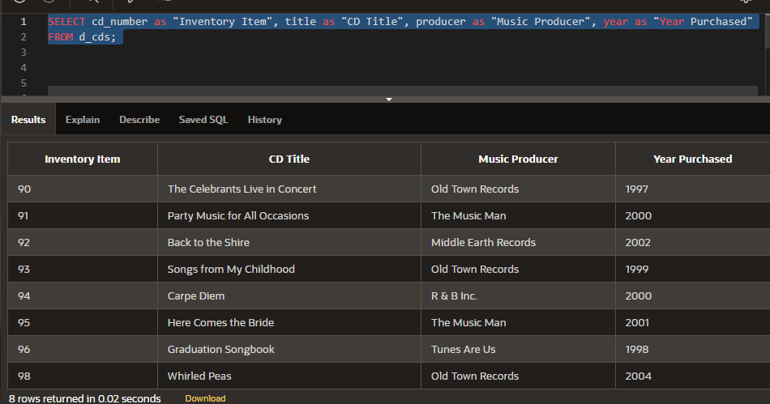

1. True-- The following SELECT statement executes successfully: SELECT last_name, job_id, salary AS Sal

FROM employees;

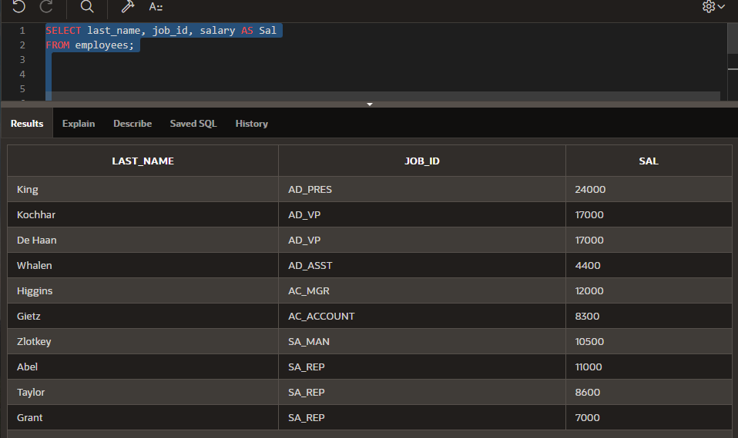

1. True -- The following SELECT statement executes successfully: SELECT *

FROM job_grades;

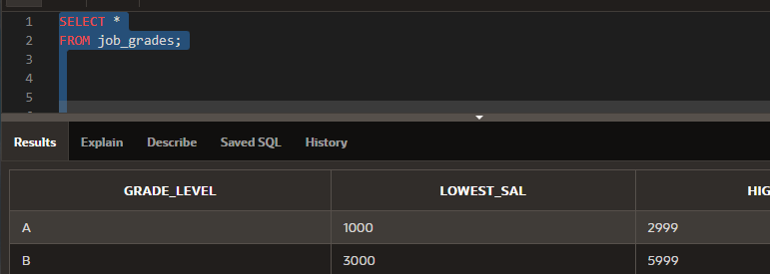

1. There are four coding errors in this statement. Can you identify them?

SELECT employee_id, last_name sal x 12 ANNUAL SALARY

FROM employees;

SELECT employee_id, last_name, salary*12 "ANNUAL SALARY"

FROM employees;

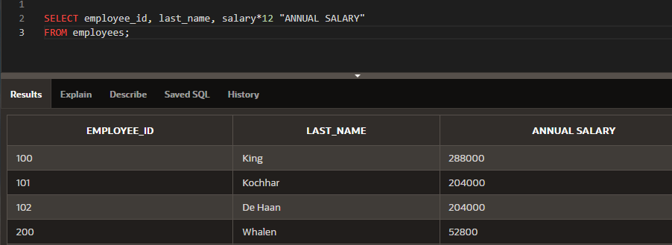

1. In the arithmetic expression salary*12 - 400, which operation will be evaluated first?

* умножение

1. Which of the following can be used in the SELECT statement to return all columns of data in the Global Fast Foods f_staffs table?
   1. column names
   2. *
   3. DISTINCT id
   4. both a and b
2. Using SQL to choose the columns in a table uses which capability?
   1. selection
   2. projection
   3. partitioning
   4. join
3. SELECT last_name AS "Employee". The column heading in the query result will appear as:
   1. EMPLOYEE
   2. employee
   3. Employee
   4. "Employee:
4. Which expression below will produce the largest value?
   1. SELECT salary*6 + 100
   2. SELECT salary* (6 + 100)
   3. SELECT 6(salary+ 100)
   4. SELECT salary+6*100
5. Which statement below will return a list of employees in the following format? Mr./Ms. Steven King is an employee of our company.
   1. SELECT "Mr./Ms."||first_name||' '||last_name 'is an employee of our company.' AS "Employees"

FROM employees;

* 1. SELECT 'Mr./Ms. 'first_name,last_name ||' '||'is an employee of our company.' FROM employees;
  2. SELECT 'Mr./Ms. '||first_name||' '||last_name ||' '||'is an employee of our company.' AS "Employees"

FROM employees ;

* 1. SELECT Mr./Ms. ||first_name||' '||last_name ||' '||"is an employee of our company." AS "Employees"

FROM employees

1. Which is true about SQL statements?
   1. SQL statements are case-sensitive
   2. SQL clauses should not be written on separate lines.
   3. Keywords cannot be abbreviated or split across lines.
   4. SQL keywords are typically entered in lowercase; all other words in uppercase.
2. Which queries will return three columns each with UPPERCASE column headings?
   1. SELECT "Department_id", "Last_name", "First_name" FROM employees;
   2. SELECT DEPARTMENT_ID, LAST_NAME, FIRST_NAME FROM employees;
   3. SELECT department_id, last_name, first_name AS UPPER CASE FROM employees
   4. SELECT department_id, last_name, first_name FROM employees;
3. Which statement below will likely fail?
   1. SELCT * FROM employees;
   2. Select * FROM employees;
   3. SELECT * FROM EMPLOYEES;
   4. SelecT* FROM employees;
4. Click on the History link at the bottom of the SQL Commands window. Scroll or use the arrows at the bottom of the page to find the statement you wrote to solve problem 3 above. (The one with the column heading SuperStar). Click on the statement to load it back into the command window. Execute the command again, just to make sure it is the correct one that works. Once you know it works, click on the SAVE button in the top right corner of the SQL Commands window, and enter a name for your saved statement. Use your own initials and “_superstar.sql”, so if your initials are CT then the filename will be CT_superstar.sql.

Log out of OAE, and log in again immediately. Navigate back to the SQL Commands window, click the Saved SQL link at the bottom of the page and load your saved SQL statement into the Edit window. This is done by clicking on the script name. Edit the statement, to make it display + instead of *. Run your amended statement and save it as initials_superplus.sql.

